**Q1.find out the mail servers of the following domain:**

[**www.Ibm.com**](http://www.Ibm.com)

[**www.wipro.com**](http://www.wipro.com)

Ans: with the help of command nslookup found following information about domains.

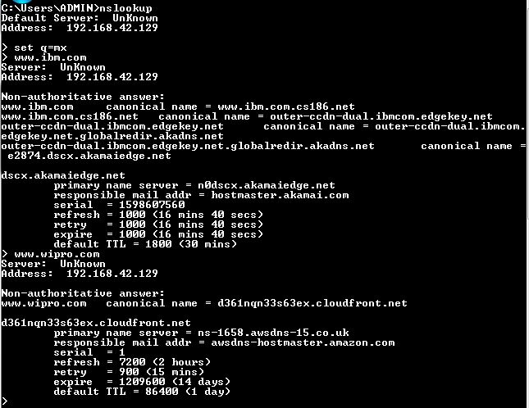 [www.ibm.com](http://www.ibm.com) has mail address “hostmaster.akamai.com” & [www.wipro.com](http://www.wipro.com) has awsdns-hostmaster.amazon.com mail address.

**Q2.find the locations, where these email servers are hosted.**

Ans: we cannot trace locations without having headers in emailtrackerpro.

**Q3.scan and find ort numbers open 203.163.246.23.**

**Ans**. All the ports are filtered on 203.163.246.23,

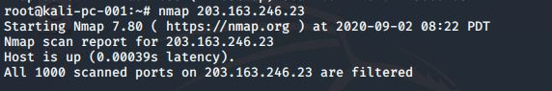

**Q4.Install Nessus in a VM and scan your laptop/destop for CVE**

**Ans.**